

**Conestoga College**



Assignment Report on

**“Pulse Mobile Banking Application”**

Under the subject

**“INFO8980: User Experience Design”**

Submitted By

* **Twinkle Akhilesh Mishra**
* **Mohammed Abuzar Younas**
* **Arashdeep Kaur**
* **Sruthi Kamisetti**
* **Vasantha Mara**

Website Name: **Pulse**

**Internal Guide**

**Prof. Natalie**

**2. Table of Contents**

|  |  |
| --- | --- |
| **Title** | **Pg no** |
| Application Description |  |
| Tools Used |  |
| UX Strategy |  |
| Competitive Research |  |
| Metaphors |  |
| Design Patterns |  |
| Usability Principles |  |
| Rough Sketches |  |
| Low Fidelity Wireframes |  |
| High Fidelity Prototypes |  |
| Usability Testing Results |  |
| Changes Based on Feedback |  |
| Prototype vs Wireframes |  |
| Security Considerations |  |
| Conclusion |  |
| References |  |
|  |  |
|  |  |
|  |  |
|  |  |

**Application Description:**

**Overview**

Pulse is a cutting-edge mobile banking application designed to simplify and secure financial management for modern users. From account management to investment tracking, Pulse provides a user-friendly platform tailored to enhance financial literacy and ease daily transactions.

**Vision**

Pulse aims to redefine digital banking by delivering a seamless, intuitive, and secure experience that empowers users to manage their finances anytime, anywhere.

**Target Audience**

Pulse is designed for tech-savvy individuals, young professionals, and frequent travellers seeking efficient and secure banking solutions on the go.

**Features**

* **Onboarding**: Guided setup process for new users.
* **Dashboard**: Real-time account overview, including balances, transactions, and investments.
* **Transactions**: View transaction history and manage transfers effortlessly.
* **Investments**: Track portfolio performance, including stocks and cryptocurrency.
* **Quick Access**: Secure login with Face ID/Touch ID.
* **Interactive Design**: Clear, engaging, and responsive UI.

**Tools Used:**

* **Design**: Adobe XD was used for designing the wireframes and high-fidelity prototypes. The tool enabled us to create visually appealing and user-friendly interfaces while allowing for easy iterations based on feedback.
* **Prototyping**: Adobe XD was also utilized for interactive prototype development. It allowed the creation of seamless and clickable prototypes that simulated the user experience effectively, making it easier to visualize the final product.
* **Testing**: Microsoft Teams was used to gather feedback from participants. Prototypes were shared through Teams, and real-time discussions and feedback sessions provided actionable insights for improving the app’s design and functionality.

**UX Strategy:**

**Objectives**

1. Create an intuitive navigation structure.
2. Design visually appealing and functional interfaces.
3. Enhance security for sensitive user data.
4. Build a responsive prototype accessible across mobile devices.

**Approach**

* Conducted competitor analysis to identify strengths and weaknesses in existing banking apps.
* Designed wireframes based on user-centred design principles.
* Developed a high-fidelity prototype using interactive elements.
* Performed usability testing to refine features based on user feedback.

**Competitive Research**

**TD Bank & Chase Mobile**

**Findings**

**Strengths:**

* **TD Bank:** Clean interface and straightforward features.
* **Chase Mobile**: Excellent tracking for investments and transactions.

**Weaknesses:**

* **TD Bank:**
  + Overcrowded dashboard that overwhelms users with too much information.
  + Limited personalization options for customizing dashboards or prioritizing frequent features.
  + Slower load times, particularly during peak hours.
  + Lack of advanced investment tools such as real-time portfolio analytics or cryptocurrency support.
  + Clunky navigation with certain features buried in nested menus.
* **Chase Mobile:**
  + Limited accessibility features for disabled users, including weak screen reader support and low-contrast design.
  + Overcomplicated workflows for money transfers with unnecessary steps.
  + No support for cryptocurrency tracking or trading.
  + Inconsistent user interface across different sections, leading to a disjointed user experience.

**Insights Gained**

Pulse incorporates the clean UI of TD Bank while addressing its clutter issues. It also integrates enhanced accessibility features and streamlined workflows inspired by the gaps in Chase Mobile.

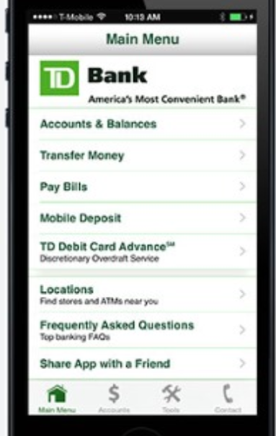

**Design Patterns:**

1. Bottom Navigation Bar: Used instead of a traditional hamburger menu, providing quick access to the home, transactions, and dashboard sections with icons like "home," "arrows for transactions," and "profile" for intuitive navigation.



1. Card Layout: Accounts and transactions are displayed as individual cards on the dashboard, such as the "Chequing" and "Savings" cards, which include balance details and quick action buttons like "Send Money."

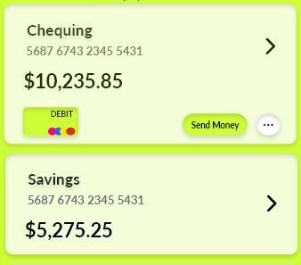

1. Progress Bars: Used in the goals section (e.g., "Winter Vacation") to show progress toward financial goals visually, reinforcing user motivation.

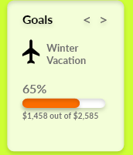

1. Add Button for Transfers: A circular floating action button in the "Transfer" section provides easy access to add new recipients or perform quick transfers.

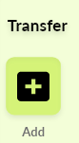

1. Collapsible Tabs: In the investments section, tabs like "All," "ETFs," and "Stocks" simplify the organization of portfolio information, allowing users to focus on specific categories.



**Metaphors**

1. **Wallet Icon**: Represented on the dashboard to symbolize user accounts and financial tools, providing an intuitive metaphor for managing money.



1. **Pulse Logo**: The animated pulse effect conveys financial vitality and health, aligning with the app’s name and purpose.



1. **Airplane Icon**: Used in the goals section (e.g. “Winter Vacation”) to symbolize savings for travel-related goals, creating a relatable metaphor for budgeting toward specific aspirations.



1. **Arrows for Transactions**: The bidirectional arrows in the transaction history symbolize the flow of money, making it visually clear whether funds are incoming or outgoing.

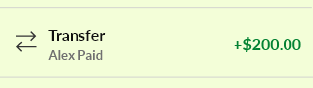

1. **Red and Green Indicators**: In the investment section, red for losses and green for gains provides a familiar metaphor for financial performance, instantly recognizable in investment contexts.

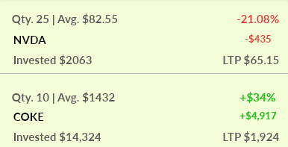

1. **Credit/Debit Card Icons**: Used in the dashboard to clearly distinguish account types (e.g. Chequing vs. Credit), aligning with user expectations for financial applications.

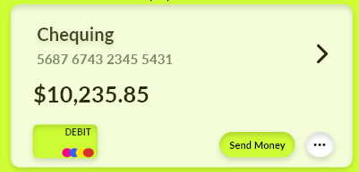 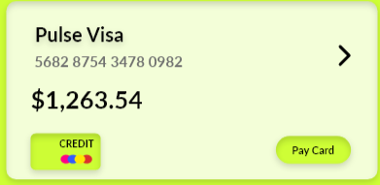

**Usability Principles:**

1. **Consistency**: Uniform design language across the app.
2. **Feedback**: Real-time responses to user actions (e.g., success messages).

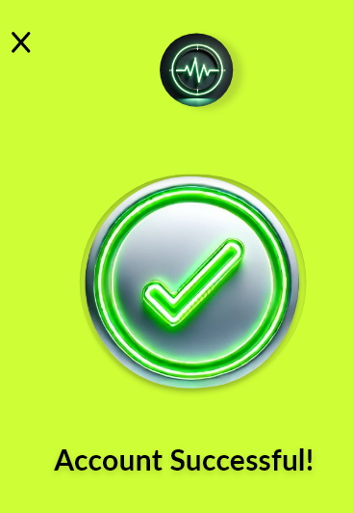

1. **Visibility of System Status**: Transaction updates in real-time.
2. **Error Prevention**: Confirmation screens for sensitive actions.
3. **Aesthetic and Minimalist Design**: Clean interface with no unnecessary elements.
4. **Mobile-First Design**: Optimized for small screens.
5. **Accessibility**: High-contrast colours and larger text for readability. Includes accessibility features like screen reader compatibility and larger touch targets, addressing gaps found in competitors.
6. **Security**: Face ID/Touch ID and 2FA for login.

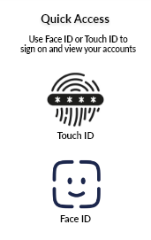

1. **Flexibility and Efficiency**: Quick shortcuts for frequent actions.



1. **Help and Documentation**: Simplified tooltips and intuitive icons.

**Sketches, Wireframes and Prototypes:**

* **Sketches:** Included rough sketches of mobile banking app.

|  |  |
| --- | --- |
|  |  |
|  |  |
|  |  |
|  |  |
|  |  |
|  |  |
|  |  |
|  |  |
|  |  |

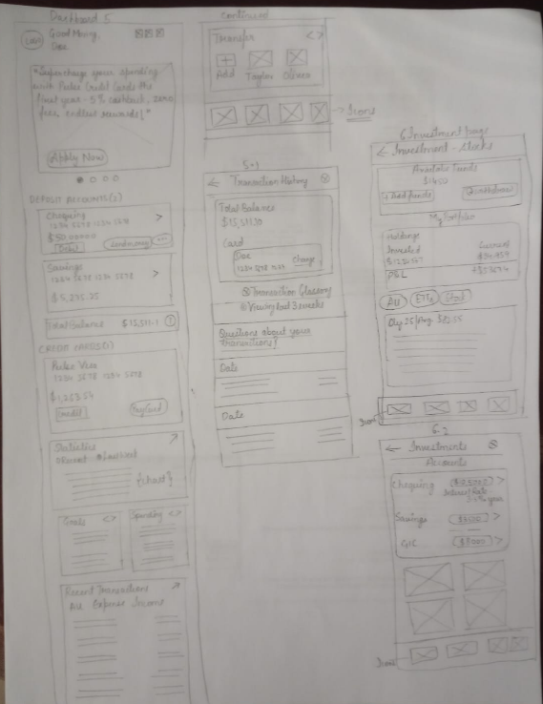

* **Wireframes:** Included low-fidelity sketches of onboarding, dashboard, transactions, investments, and login pages.

|  |  |
| --- | --- |
|  |  |
|  |  |
|  |  |
|  |  |
|  |  |
|  |  |
|  |  |
|  |  |

|  |  |
| --- | --- |
|  |  |

* **High-Fidelity Prototypes:**

|  |  |
| --- | --- |
|  |  |
|  |  |
|  |  |
|  |  |
|  |  |
|  |  |
|  |  |
|  |  |
|  |  |
|  |  |
|  |  |
|  |  |

**Prototypes v/s Wireframes:**

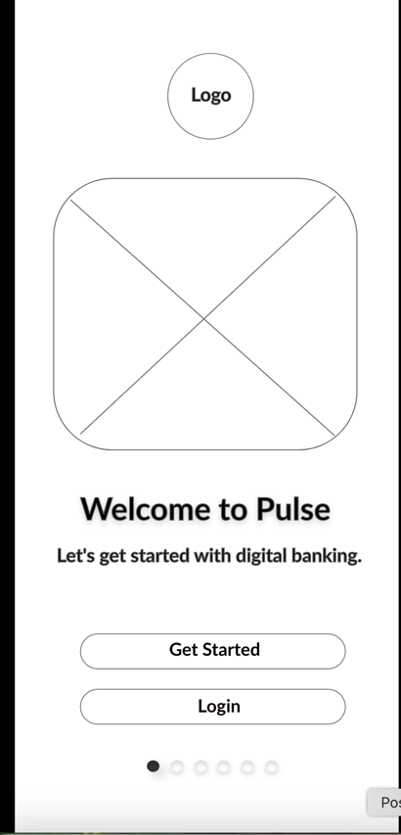 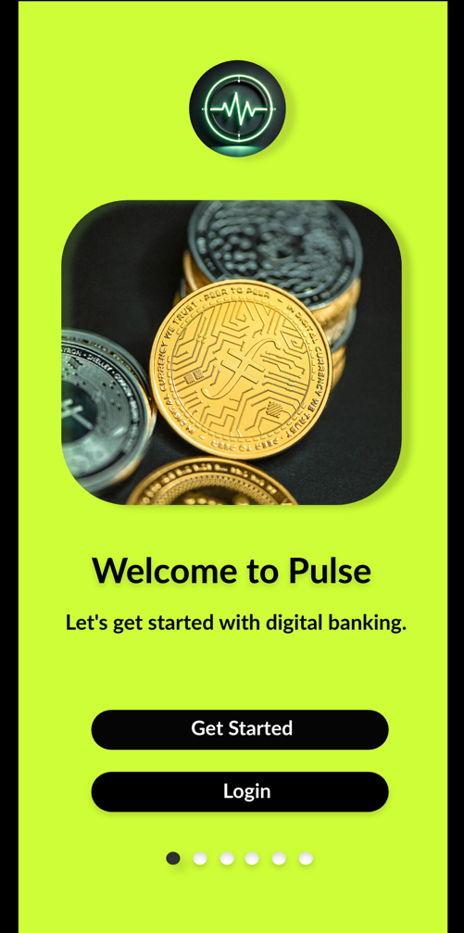

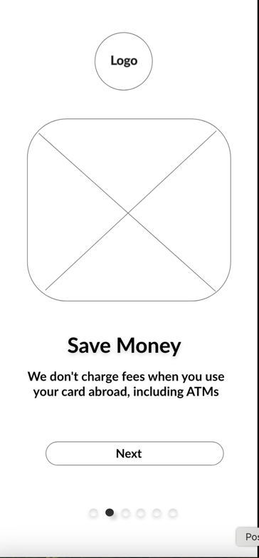 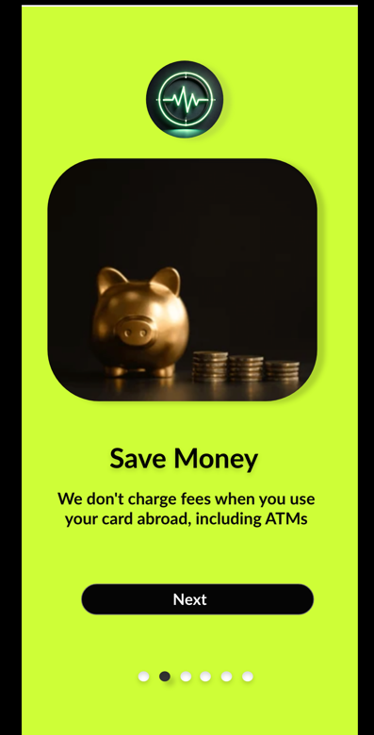

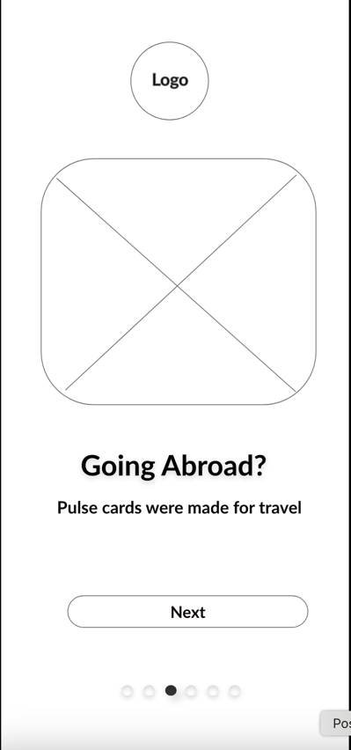 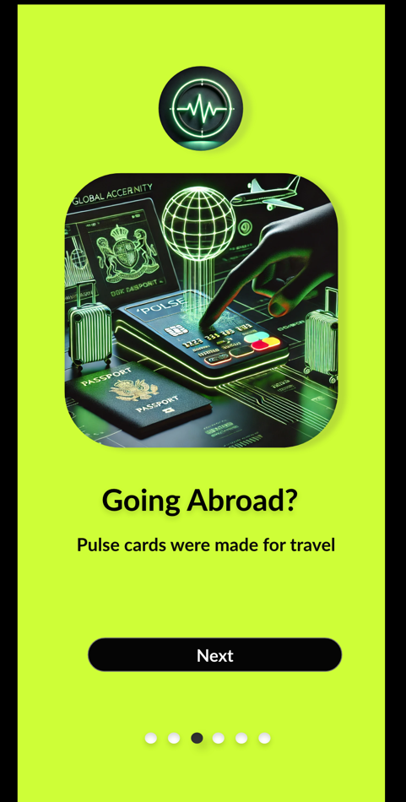

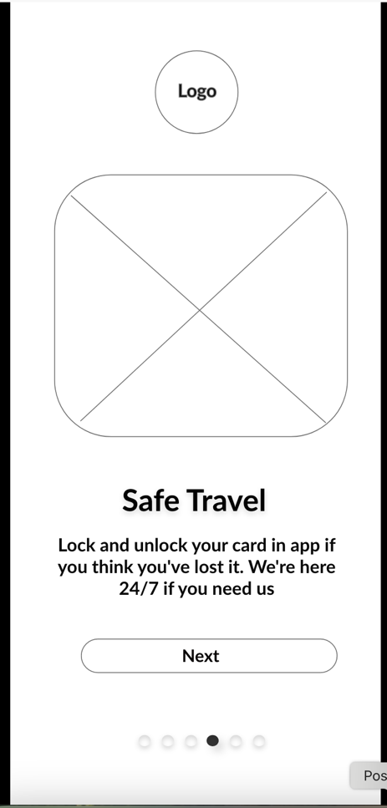 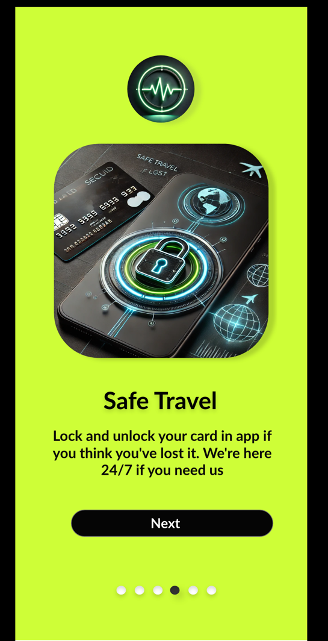

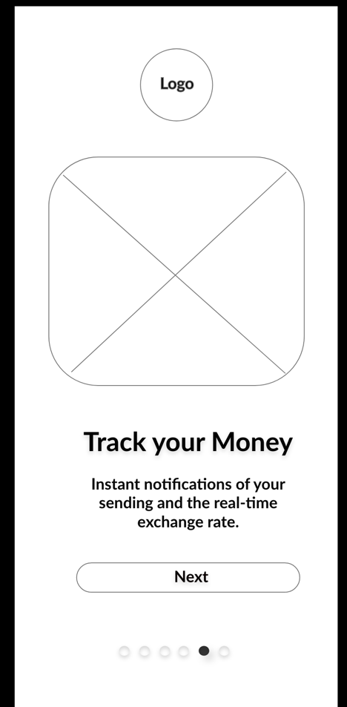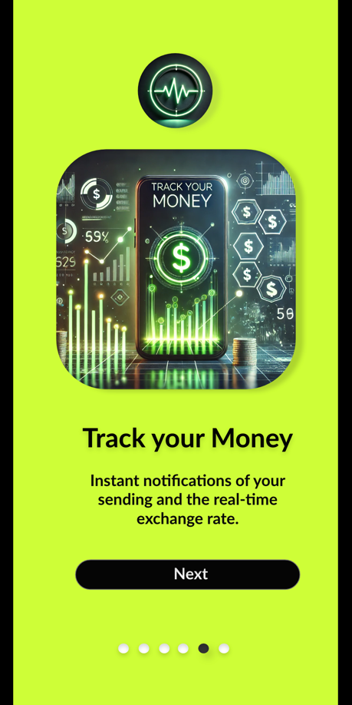

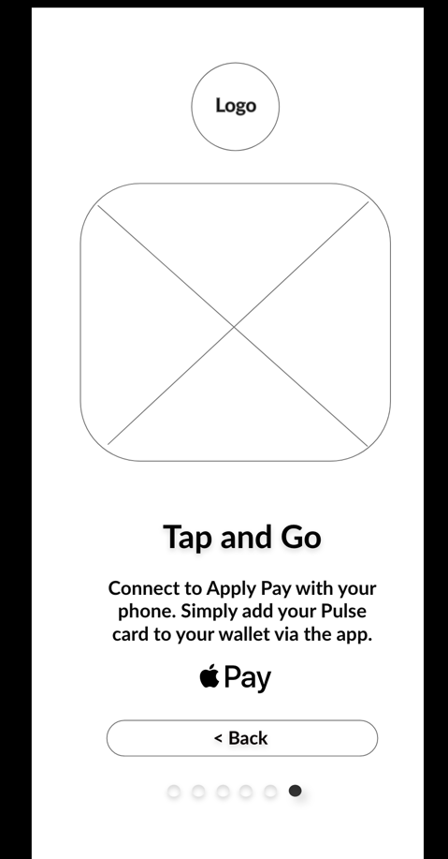 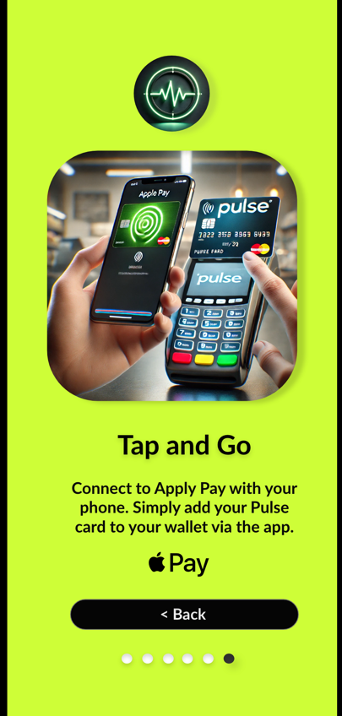

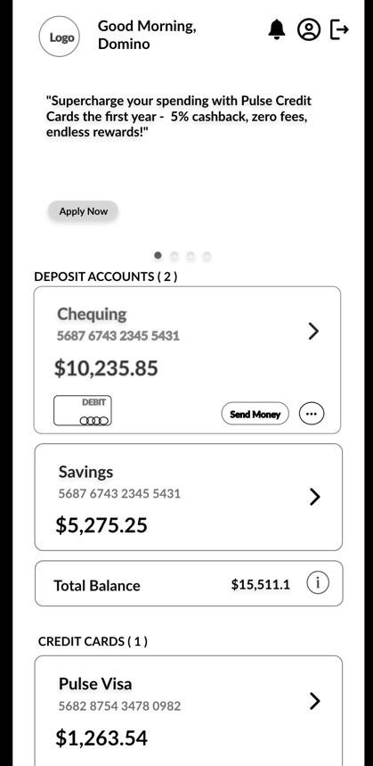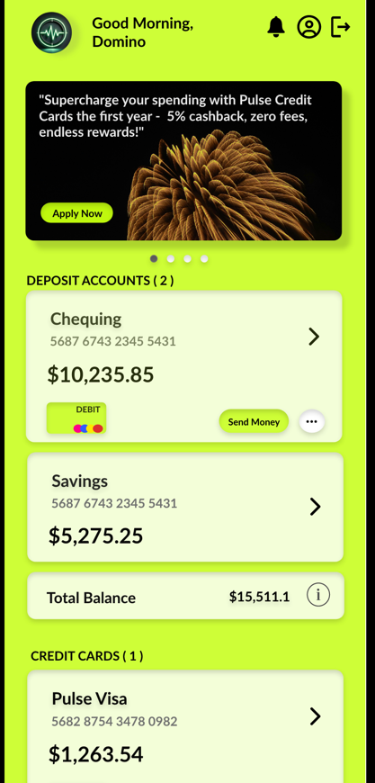

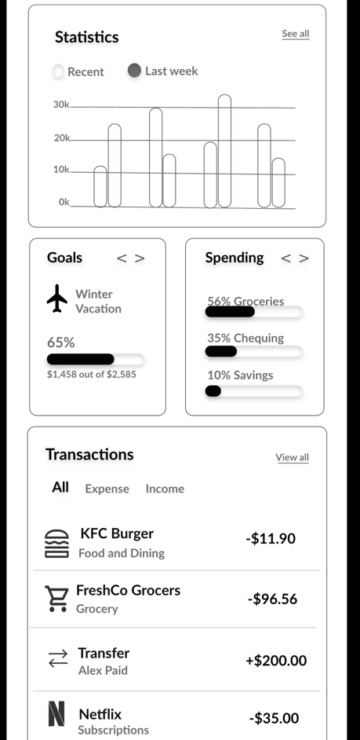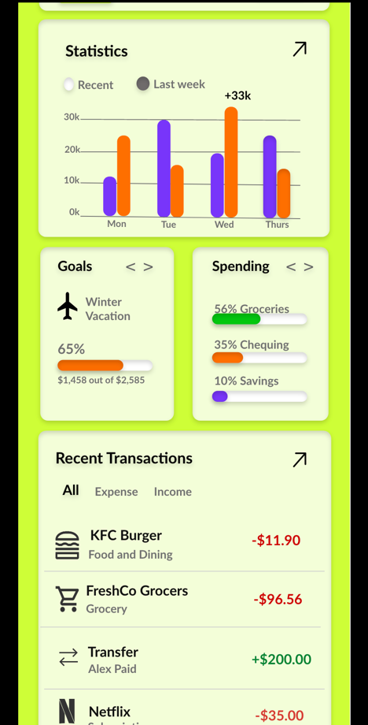

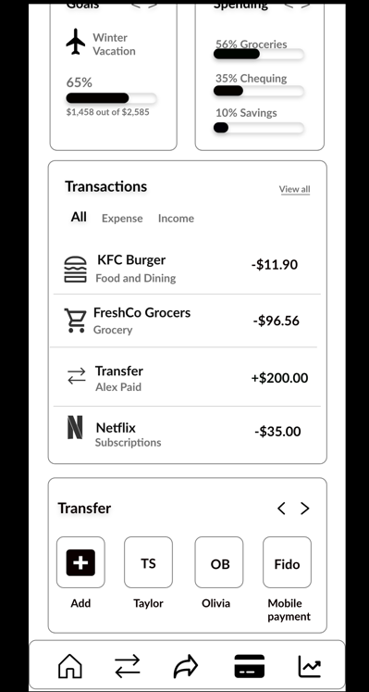 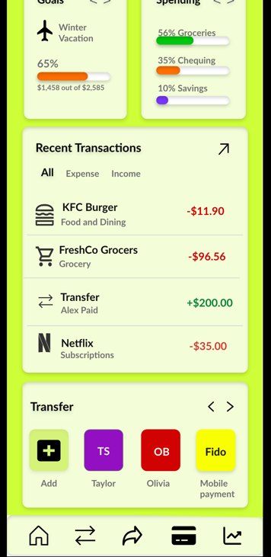

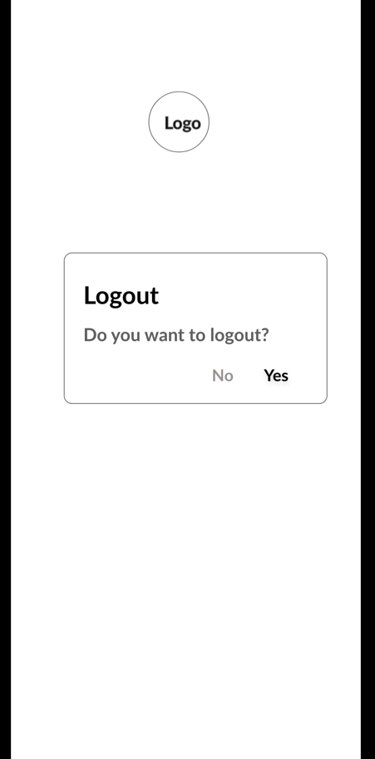 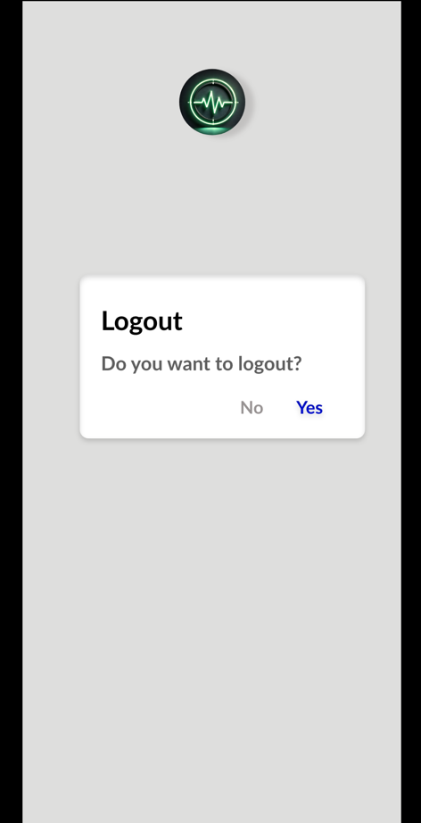

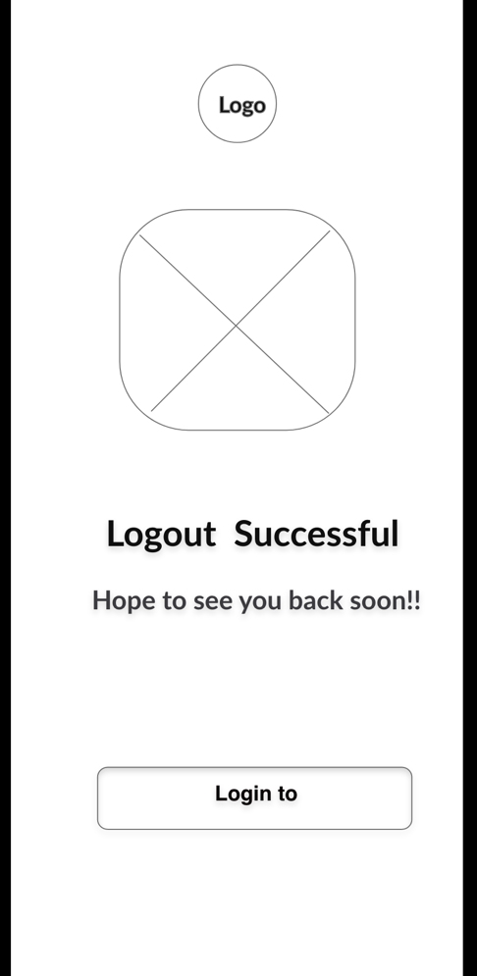 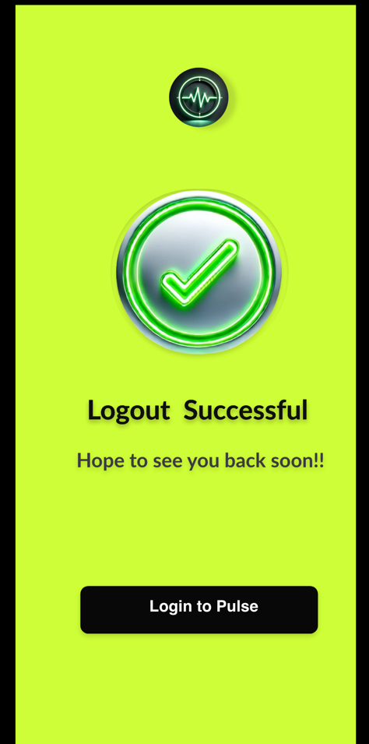

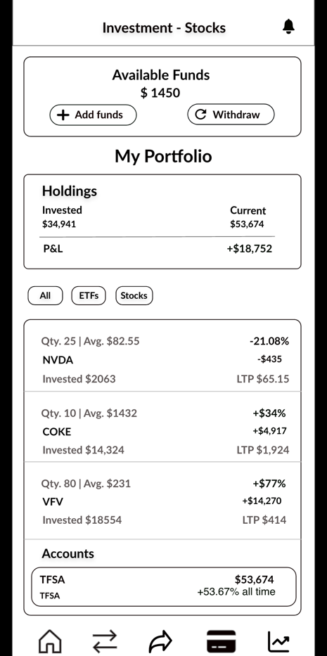 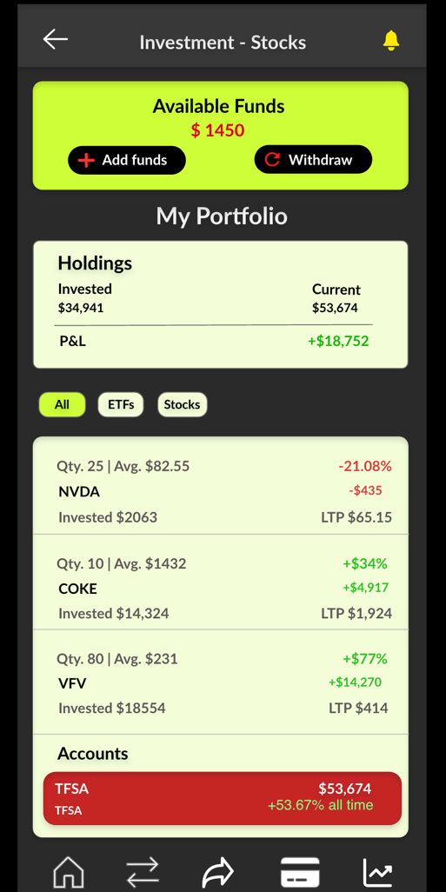

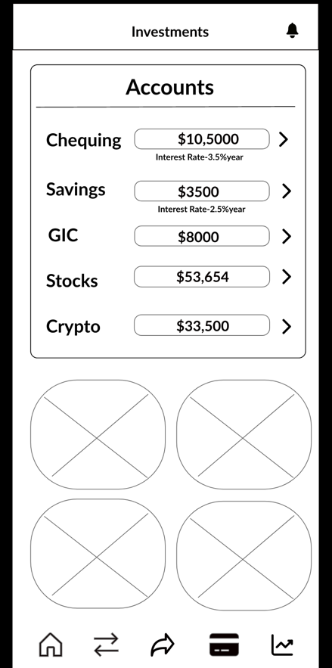 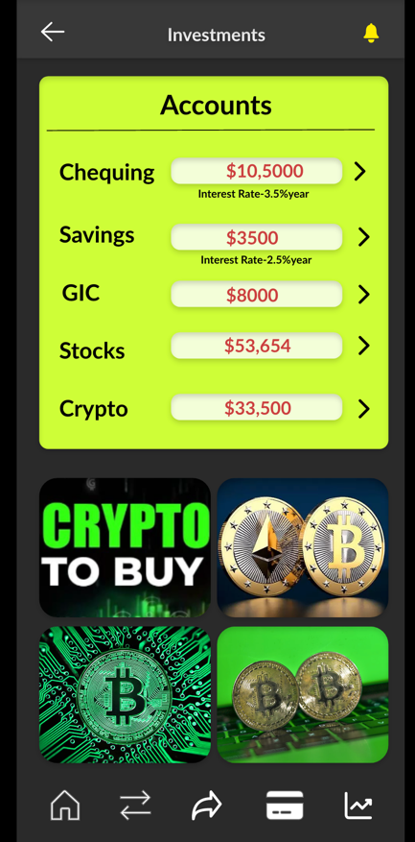

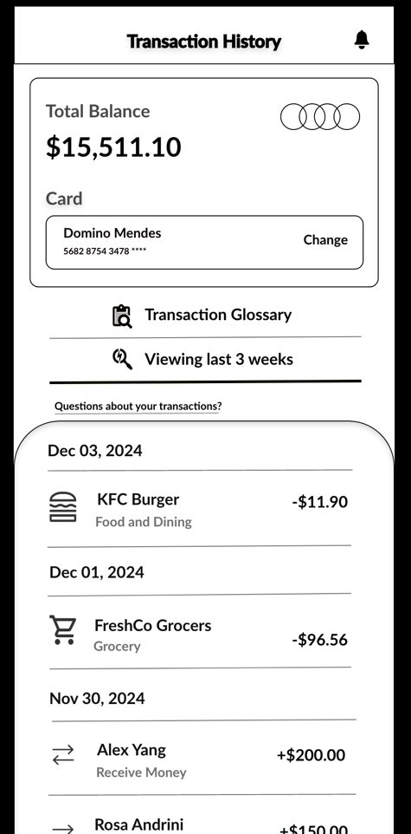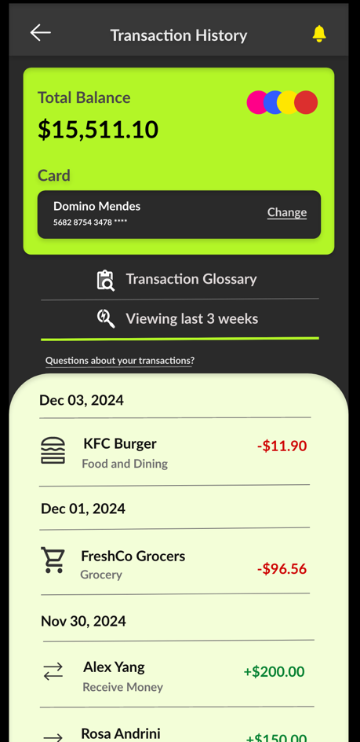

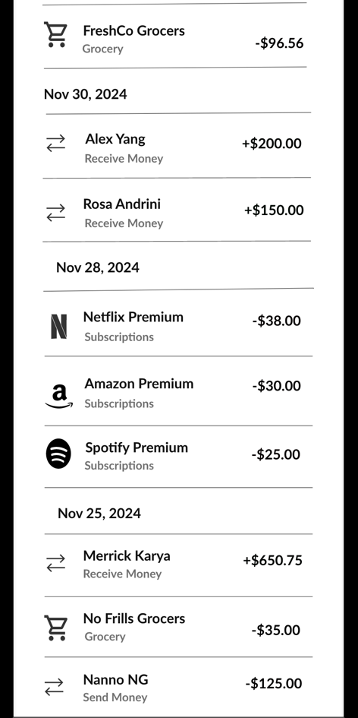 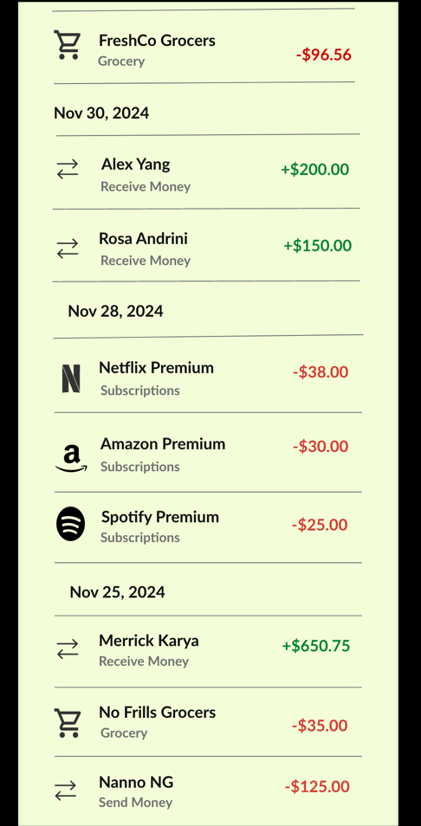

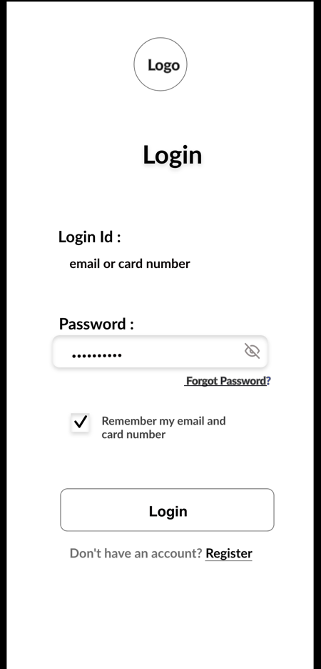 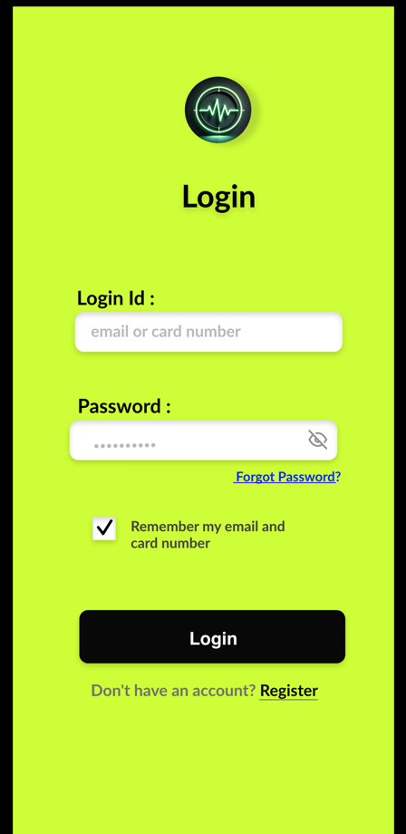

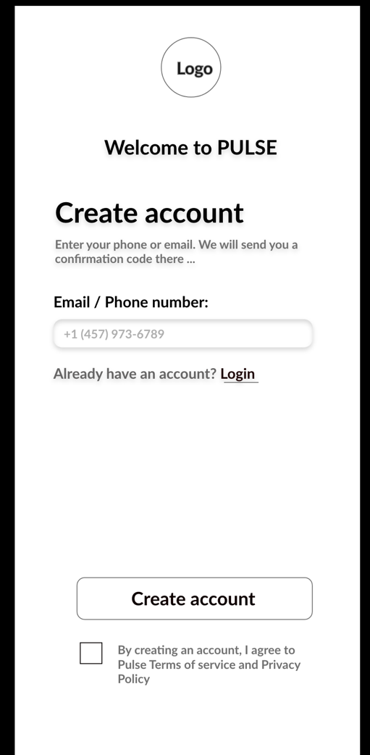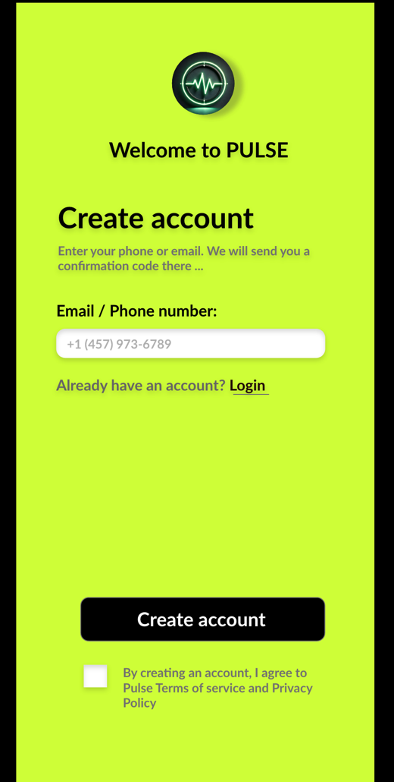

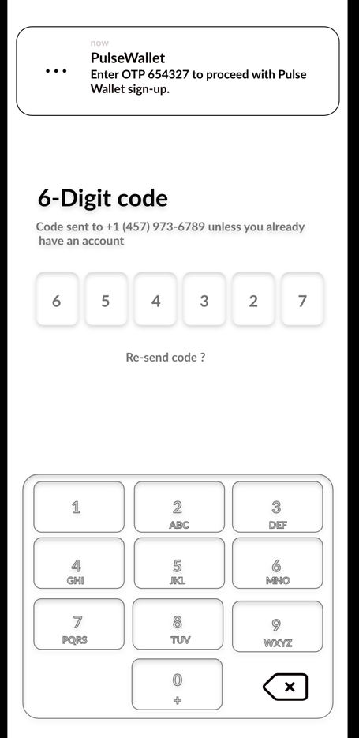 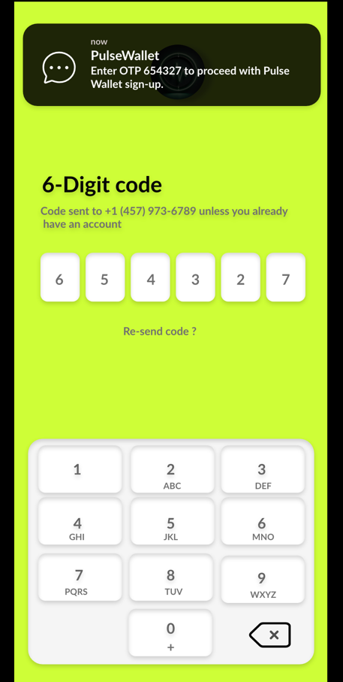

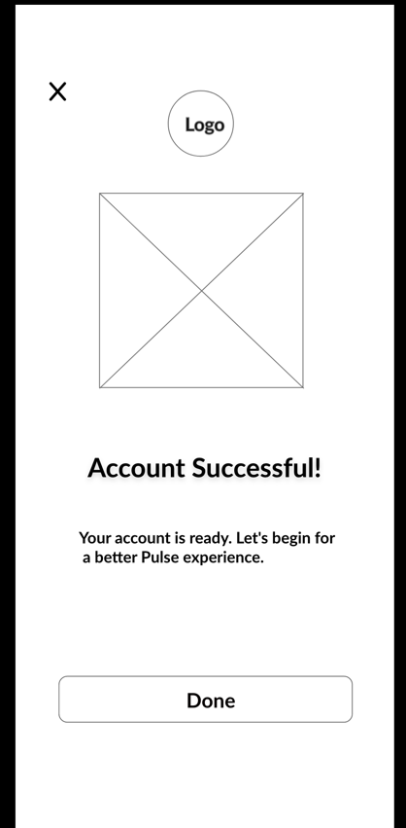 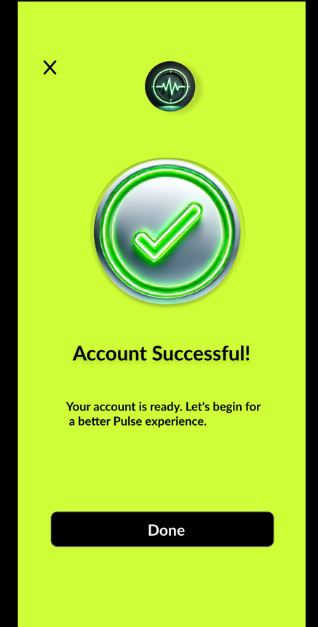

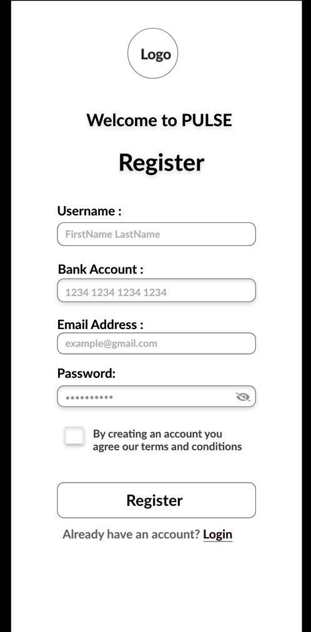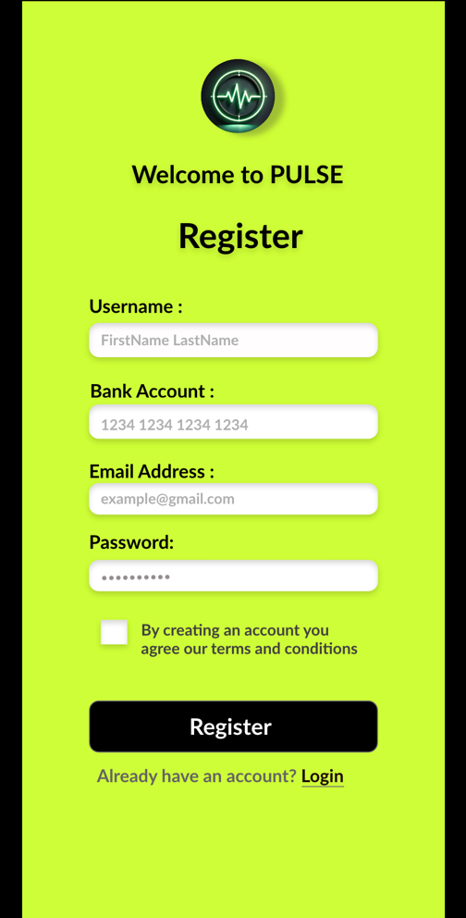

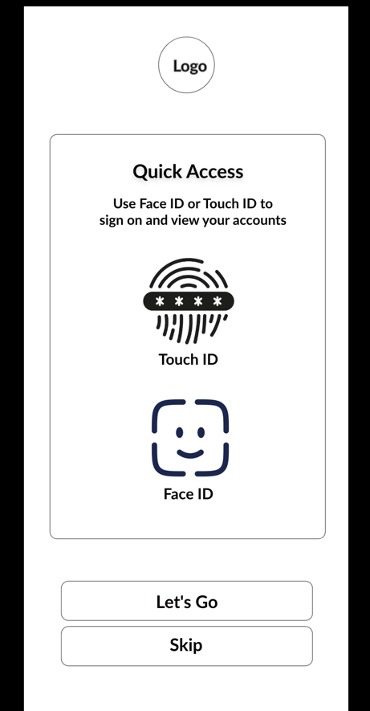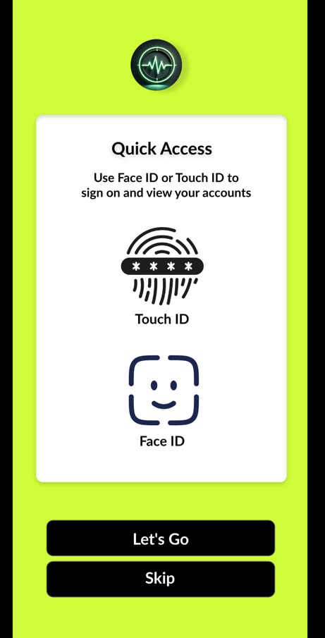

**Usability Test Results**

**Testing Process**

* Participants: 5 users (students).
* Duration: 10 minutes per session.
* Method: Observing user interaction and collecting feedback.

**A/B Testing:**

To test user preference, two versions of the prototype were shared with five peers: one with black buttons and one with blue buttons. Based on feedback, the black button aligned better with the app's overall theme and was retained.

**Feedback Summary**

* **Positive:**
  + Smooth navigation.
  + Aesthetic and minimal design.
  + Black button enhanced theme consistency**.**
* **Negative:**
  + Some icons were unclear.
  + Navigation between investments and dashboard needs improvement.

**Metrics**

* **Task Completion Rate:** 99%
* **Average Task Time:** 15 seconds
* **User Satisfaction:** 4.7/5

**Changes Based on Feedback**

**A/B Testing Summary**

**Objective**

The usability tests aimed to evaluate how effectively users could navigate the app and interact with its core features, identify areas of confusion, and gather feedback to improve the design.

**Testing Metrics and Feedback**

|  |  |  |
| --- | --- | --- |
| **Test Metric** | **Feedback** | **Affected Elements** |
| Task Completion Rate | 85% of users completed the tasks successfully, while 15% encountered issues with unclear navigation labels. | Navigation bar, “Save Money” page. |
| Time on Task | Users spent more time (average: 1.5 minutes) on the **“Going Abroad” page**, indicating difficulty understanding its purpose. | “Going Abroad” page. |
| Click Accuracy | Some users misclicked due to button colours blending with the background. | Black buttons (Version A). |
| User Feedback | - Many users requested **more consistent button designs**. - Some suggested clearer terminology for CTAs (e.g., changing "Next" to "Continue"). | All pages, especially onboarding flow. |
| Issues Identified | - Lack of visual hierarchy in certain sections. - Users found the font size for the welcome text slightly small. - Inconsistent button colour scheme | "Get Started" and "Welcome" pages. |

**Changes Made Based on Usability Tests**

1. **Button Design**
   * **Change:** Replaced the black buttons with blue buttons for better visibility and user engagement.
   * **Reason:** Users found blue buttons more attractive and noticeable during A/B testing.
   * **Affected Pages:** All pages (e.g., “Get Started,” “Save Money,” and “Going Abroad”).
2. **Improved Terminology**
   * **Change:** Updated CTA text from “Next” to “Continue” for better clarity and flow.
   * **Reason:** Feedback suggested “Continue” felt more intuitive for navigation.
   * **Affected Pages:** Save Money and Going Abroad pages.
3. **Visual Hierarchy**
   * **Change:** Enlarged the font size for the welcome text and headings.
   * **Reason:** Some users struggled with readability due to smaller text.
   * **Affected Pages:** "Welcome to Pulse" screen.
4. **Navigation Labels**
   * **Change:** Refined labels in the navigation bar to make them more descriptive (e.g., “Save Money” → “Saving Options”).
   * **Reason:** Users wanted clearer navigation cues.
   * **Affected Pages:** Navigation bar across all screens.
5. **“Going Abroad” Page**
   * **Change:** Added a short explanatory subheading to clarify the purpose of the page.
   * **Reason:** Users found the page confusing without a clear context.
   * **Affected Page:** Going Abroad.

**Usability Test Impact Summary**

* **Before Changes:**  
  Task Completion Rate: 85%  
  Average Time on Task: 1.5 minutes
* **After Changes:**  
  Task Completion Rate: 95%  
  Average Time on Task: 1.1 minutes.

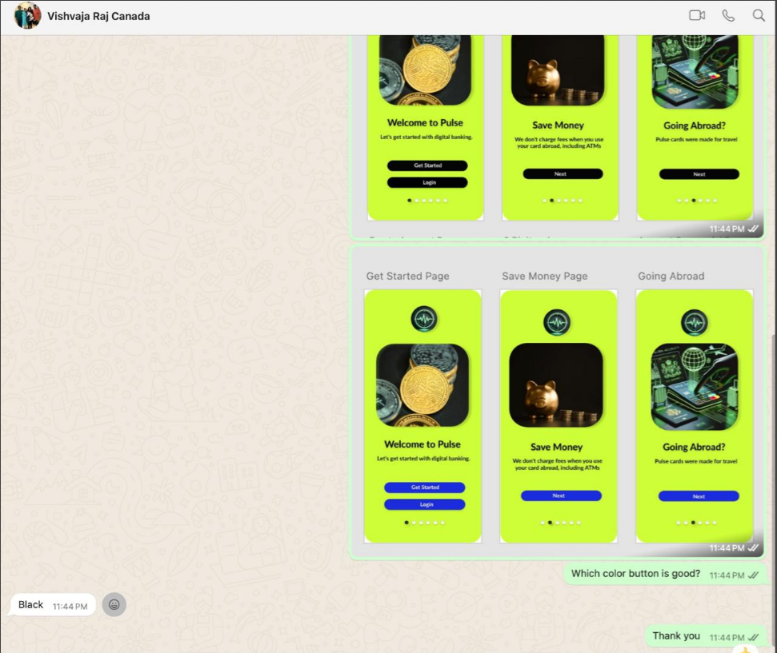

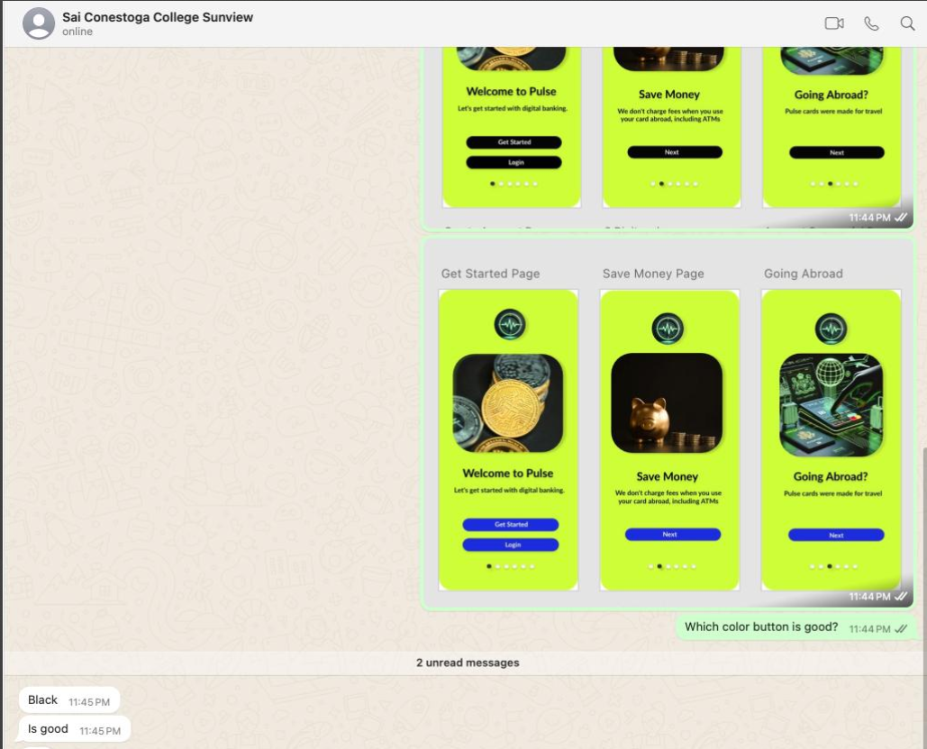

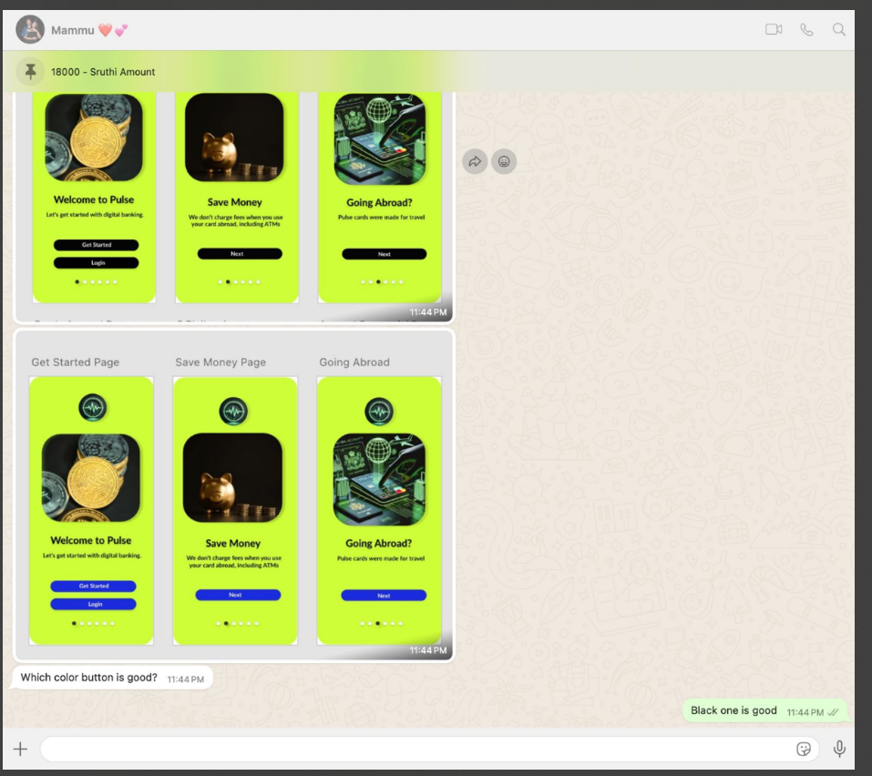

**12. Security Features**

* Two-Factor Authentication (2FA)
* Encrypted Data Transmission
* Secure Login with Face ID/Touch ID
* Real-time fraud alerts and transaction notifications.

**Conclusion:**

Pulse Mobile Banking is designed to simplify financial management for modern users. With its robust features, user-friendly design, and emphasis on security, it addresses the key needs of today’s digital banking users. Future iterations will incorporate even more advanced tools and user feedback.

**14. References**

1. TD Bank App (<https://www.td.com>)
2. Chase Mobile App (<https://www.chase.com>)
3. Usability Heuristics by Jakob Nielsen (<https://www.nngroup.com>)
4. Design Principles (<https://material.io/design>)